**On-page SEO:** (also called on-site SEO) is the practice of optimizing web pages to rank higher in search engines. It includes optimizations to visible content and the HTML source code. Why is on-page SEO important? Google looks at your page’s content to determine whether it’s a relevant result for the search query.

**What is on page SEO:**

On page SEO involves those SEO strategies or techniques that are performed within the website and are under your control. It is the practice of optimizing web pages in order to get more and [more traffic](https://www.tendtoread.com/how-to-increase-organic-search-traffic/) and accordingly to increase the rank in Google SERP. It refers to both content and HTML source code optimization.

**Why on page SEO techniques are important:**

The benefits of on page SEO techniques are enormous. The performance of a website mainly depends on the optimization of the content and the codes and it is nevertheless to say that on page SEO plays the major role here. On page SEO is important because it helps in-

* Increase website traffic and users
* Get the best ROI
* Increase business leads
* Ranking higher in Google SERP
* Boosting organic traffic
* Helps in local SEO
* Speeds up website loading speed
* Improves CTR (click-through rate)
* Enhances crawl rate etc

**On page SEO techniques checklist:**

With the ever changing Google algorithms it is quite not easy to keep yourself updated all the time about the changes that have been made. But that is what can set you apart from others in the run and give you extra benefits. Following are some of the most important SEO techniques. Though the basic points and the newest techniques are not far apart from the previous ones, but the latest on page SEO techniques 2021 have definitely got some noticeable changes that must be considered.

### ****Keyword optimization:****

Before you go for ‘content is the king’, you should know that it is the keywords that make content the king. Thorough research on keywords should be made before you start writing your content. Google is behaving smarter than before regarding keywords. Use your targeted keywords throughout the content but don’t overdo it. Keyword stuffing is a BIG NO in SEO. Now Google can catch the synonyms as well and tries to show the best results when someone ask for the same.

Try to use your keywords in the title, url and meta description. It is good if you can use the primary keyword once in the first paragraph of your content. For the best keywords optimization you can use [SEMRUSH keyword magic tool](https://www.semrush.com/lp/backlinks/en/?ref=5659998657&refer_source=tendtoread&utm_campaign=landing_backlink_management_multi_tool&utm_source=berush&utm_medium=promo&utm_term=36), but if you don’t have budget for this then you can use Google SERP suggestion LSI keywords for the best result and you can get ideas about the keywords.

### ****Content optimization:****

Content optimization is one of the best SEO techniques. Let’s describe it in two parts- quality content and fresh content. Quality content refers to content that is keyword rich, relevant and that contains proper information. If your website appears for a particular keyword search you should make it clear that your site has enough data and complete information of the topic. Otherwise after landing on your page, if visitors do not get the proper relevancy of your content they will leave your site soon and never visit again this way you will not only lose traffic but also the bounce rate will increase which is not at all good for any website. Google always prefers fresh content. So try to put new content and update the old ones in your website at regular interval of time.

What is the ideal length of a blog’? That’s a common question. Honestly, the answer is not much certain. There are different blogs in the internet that ranges from around 300-5000. But with recent data ideal blog length in 2020 can be considered as in between 2000-2500. But it is not necessary that every blog need to be that lengthy. There are also many blogs with good number of readers that counts 1000-1500 words.

### ****Image optimization:****

Image optimization simply refers to reducing the image size without harming the quality of the image so that it doesn’t lower the speed of the website. Also, in image SEO, optimization is done so that it gets a good rank in Google SERP. Following are some key techniques that you can use regarding image optimization:

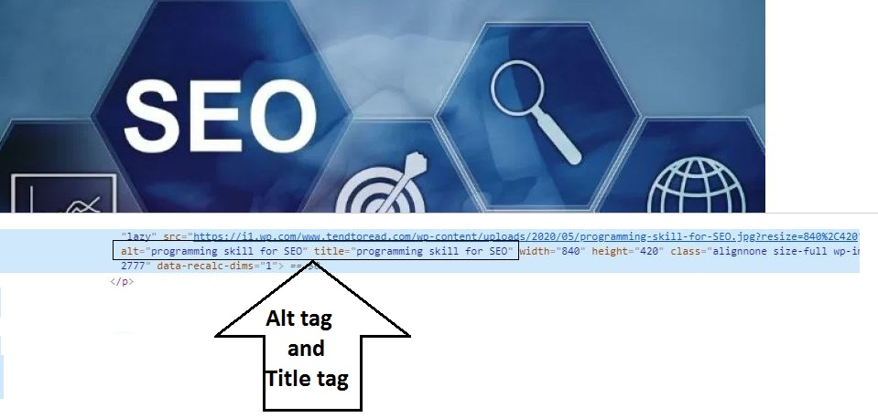

* Name your image simple and specific.
* Choose proper image pixels while resizing the image.
* Alt attribute for images is one of the most important factors. Try to include relevant keyword while adding image alt attribute.
* There are three main file types for images- JPEG (or .jpg), PNG and GIF. Choose wisely the right file type for your images.

### ****Title optimization:****

Title is the very first thing your audience will notice. Getting a good title therefore is very important. Keep your title unique and try to include keywords. This will not only attract visitor’s attention but also will help in SEO purpose. According to latest on page SEO ideal length of a title is 50-60 characters. You should keep this in mind while finalizing your page titles.

### ****Anchor text optimization****

The anchor text is the text in between the content that leads you to another website or page which is hyperlinked. In HTML code that Google reads looks like this [increase website traffic](https://www.tendtoread.com/how-to-increase-traffic-to-website/) Here ‘increase website traffic’ is the anchor text that links you to one of ‘Tend To Read’s blogs. Anchor text is an important factor in SEO as it helps your website with [backlinks](https://www.tendtoread.com/create-backlinks-manually-for-website/). Now here are some points that you need to keep in mind while optimizing an anchor text:

* Choose an attractive word or line as anchor text so that people would like to click on that and land on the linked page for further reading.
* You can choose keywords as anchor text. But do not do it repeatedly.
* Anchor text should be relevant to the page content it is liked to.
* Link the anchor text to page that has detailed information about that particular topic rather than linking it to a website’s homepage.

### ****Interlinking with proper keywords:****

Interlinking inside your own website is a good way of link building and increasing number of clicks. It helps in enhancing the page view of your site and also helps in page ranking. It is also good for decreasing bounce rate and keeps visitors stay in your site for a longer time.

This is one of the best on page SEO techniques where you can link one page to another page. If you have a page which is ranking at top position at the SERP result then you can link your un-ranked page to that rank page for the best traffic which will increase the website session and reduce the bounce rate.

### ****Check keywords prominence and keyword proximity:****

Though most of the content writers or digital marketers don’t pay much attention to this but keyword prominence should be always taken into account. For example, in the below two sentences-

“What are the latest techniques for search engine optimization&How to you optimize your site for better search engine results”

The chance of ranking the website containing the first line is more for a search in Google for ‘search engine optimization’. Moreover, keyword proximity is also an important factor. The distance between the individual keywords of the search terms should be less for better results.

### ****Long tail keywords:****

The competition is high these days. To achieve a good rank for a common and short term keyword is tough. Long tail keywords help you with this. Long tail keywords are easy to rank for any query at the SERP page. Suppose if you are targeting keywords backlinks then try to add keywords like How to generate backlinks and how to create backlinks these keywords will help your blog or site to get rank for the long tail keywords and after 6 to 12 months you might be also rank for generic keywords. So long tail keywords always provide good amount of traffic to any sites, so don’t try to ignore this types of SEO techniques. You can also prefer this article for the [long tail keywords](https://yoast.com/focus-on-long-tail-keywords/).

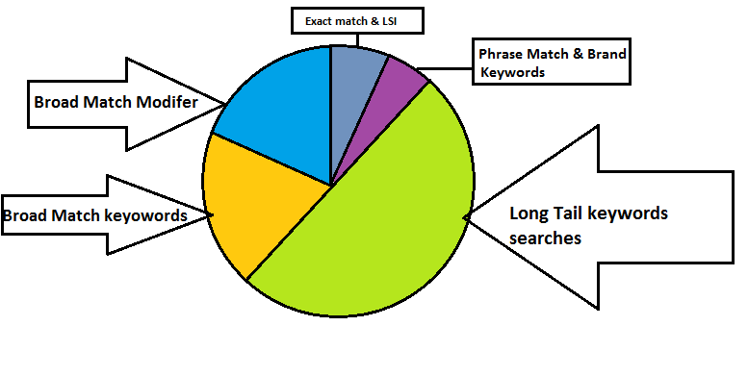

### ****Sitemap:****

Using sitemap in optimizing a website is one of the best SEO techniques of all time. It not only influences in organising a website properly but also helps search engine to crawl and index your site easily. This in turn increases the website’s visibility, allow visitors to dig more into the content which enables page links.

### ****Schema mark-up:****

Schema mark up helps the search engine to display some of very important content in the SERP. The highlighted features grab visitor’s attention easily. For example you can use mark-ups like date, star rating, review for a particular product, timing of popular events, product features, FAQ etc. There are two types of schema markup JSON-LD and Microdata. Schema mark up always help to your site for increasing CTR and little bit ranking also.

### ****URL optimization:****

A great content will be a waste if it doesn’t put to an appropriate url to be found by the search engine. The basic and foremost things to be implemented in url optimization are:

* Put a simple and understandable url.
* Do not use capital letters.
* Always put ‘–‘in between the words in the url and try to avoid other special characters.
* You can use keywords in url but do not repeat.
* Block search engine from crawling multiple urls to the same content with robots.txt.
* Add a 301 redirect in case you are changing the url that has already been crawled by search engine.